Real Estate
Investor Workshop

Presented by:
Your Name Here
Your Brand Name
Mortgage Presenter’s Name (if presenting)
Company Name
Property Management Presenter’s Name

© 2011 Keller Williams Realty, Inc
Real Estate Investor Workshop

- Why are you here today?

________________________________________________________

- What has caused you to start thinking about investing in real estate?

________________________________________________________

- Why am I here tonight?
… to share some of my thoughts on money, life, and investing in real estate.

What We Cover in the Investor Workshop
- The Possibilities
  - MythUnderstandings
  - Real Estate Investing Current Statistics
  - Your Big Why
- The Power of Leverage
  - Why Real Estate?
  - Growing Your Net Worth
- The Proven Systems
  - What to Buy
  - How to Buy

The Possibilities

- About Me
- Licensed REALTOR®
- Your Credentials
(ABR, CRS, etc.)
- Other Credentials
- I am awesome!

The Possibilities

(fĭ-năn shЭl, wĕlth)
n. The unearned income to finance your life mission without having to work.

There are eight MythUnderstandings between you and financial wealth.

Three Personal Myths
1. Myth: I Don’t Need to Be an Investor—My Job Will Take Care of
My Financial Wealth
Truth: Yes, You Do Need to Be an Investor—Your Job Is Not Your Financial Wealth

2. Myth: I Don’t Need or Want to Be Financially Wealthy—I’m Happy with What I Have
Truth: You Need to Open Your Eyes—You Do Need and Want to Be Financially Wealthy.

3. Myth: It Doesn’t Matter If I Want or Need It - I Just Can’t Do It
Truth: You Can’t Predict What You Can or Can’t Do Until You Try

The Possibilities

Five Investing Myths
1. Myth: Investing Is Complicated
Truth: Investing Is Only as Complicated as You Make It

2. Myth: The Best Investments Require Knowledge Most People Don’t Have
Truth: Your Best Investments Will Always Be in Areas You Can or Already Understand

3. Myth: Investing is Risky—I’ll Lose My Money
Truth: Investing, by Definition, Is Not Risky

4. Myth: Successful Investors Are Able to Time the Market
Truth: In Successful Investing, the Timing Finds You

5. Myth: All the Good Investments Are Taken
Truth: Every Market Has Its Share of Good Investments

National Association of REALTORS® Statistics

- 17% of all 1-4 unit home purchases in 2010 involved an investor as a buyer.
- 68% of all investors buy within 50 miles of their primary residence.
- Average sales price last year was $96K.
- 63% were single-family houses.

The Possibilities

[Your Local] Statistics

The Possibilities
Discover Your Big Why!

Why do you want to invest in real estate? ___________________________

Why is that important to you? _____________________________________

And, why is that important to you? _____________________________________

What does that mean to you? _____________________________________

Ultimately, what does THAT mean to you? ___________________________

You must dig deep into your deepest why to discover what you true Big Why is!

(You really need to take some time to do this … keep thinking about it for a few days … This is a great exercise to gain clarity in all facets of your life.)

Once you understand and know your Big Why, then:

- Big Goals - The specific, measurable targets that fulfill your Big Why

- Big Models - The proven systems and strategies for reaching your Big Goals

- Big Habits - The consistent actions and right choices that come from following Big Models

The Possibilities

There are unique propositions of investing in real estate in contrast to stocks, mutual funds, and money markets:

1. Real property is an ABLE investment; its value never goes to “zero.”

- Accessible – Anyone can buy it

- Appreciable – Increases in value over time

- Rentable – Cash flow! Cash flow! Cash flow!
(Making money while you are sleeping.)

- Improvable – Sweat equity

- Deductible/Depreciable/Deferrable – Great tax benefits

- Stable – Slow to rise and slow to fall (most of the time)

- Livable – Shelter in more ways than one.

… a Most “Able” Investment

The Power of Leverage

2. Purchasing real property can be leveraged.

Leverage: Using other people’s money (banks, mortgage companies, and owner financiers) to make money. Leverage multiplies your profit.

- Appreciation and rent are based on total value of property. Return on investment (ROI) is calculated by money invested (20% or $20,000)

- Here is the calculation, not taking rent into consideration - assuming property went up 5% (if you stick to your model when buying, this is conservative).

- 5% of $100,000 = $5,000

- $5,000 is x% of $20,000 = 25%

- To make the same money in a mutual fund yielding 10% with no costs, you would need to have $250,000 cash : “ I don’t have that, but I do have $20,000.”

The Power of Leverage

 | Stocks | Mutual Funds | Money Market | Investment Property
Start Value | $100K | $100K | $100K | $100K
Cost | $100K | $100K | $100K | $20K
Carrying Cost | 1-4% | 1-4% | n/a | mortgage offset by rent
Other Costs | 0 | 0 | 0 | 10% vacancy and maintenance
Income/Year | 8% | 10% | 2% | 5% appreciation
Other Income | 0 | 0 | 0 | rent
Adjusted ROI | 4-7% | 6-9% | 2% | 25%*
Potential Loss | 100% | 100% | 0 | 40%

Note: These are average numbers gathered from various sources and reflect only an example of each sector of investment. No guarantees of return are provided, expressed or implied. Results vary in each category, and many factors influence the return on investment, both long term and short term. We encourage you to read The Millionaire Real Estate Investor, and consult with a professional financial advisor before making any investments.

The Power of Leverage
- The Power of Leverage -- The Money Matrix
A. Financial wealth is built on capital and cash flow.

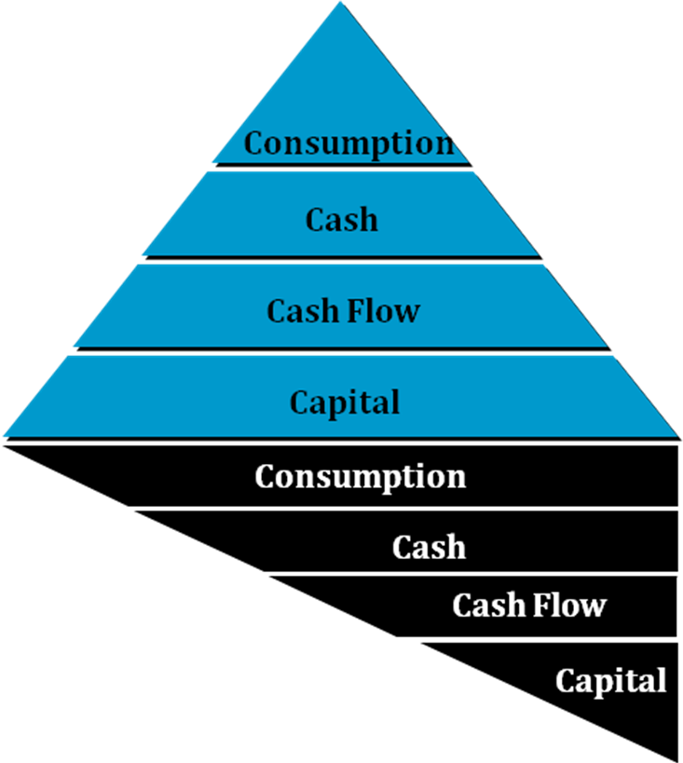
B. Shadow wealth is built on consumption and cash.

- Financial Model Part 1 - Equity Buildup
A. Value increases (appreciation).
B. Debt is paid down (by renters).
C. Your equity grows!

The Power of Leverage
- Financial Model Part 2 — Cash Flow Growth
A. Rent goes up (rent appreciation).
B. Debt is paid down (by renters).
C. Your cash flow grows!

- Why do people invest in real estate?
- Return on Investment – Less “out of pocket” for more “into pocket”!
- Tax write-offs
- Grow net worth through equity
- College Education Savings
and many more reasons …

There is no better method of investing your money!

- Tax Write-Offs*

- Operating Expenses – Management, leasing, etc.
- Mortgage Interest
- Financing costs – Points paid on the loan
- Misc. Closing Costs – Fees connected with obtaining loan
- Depreciation – Structural value of property
- Capital Improvements – New roof, siding, etc.
- Personal Property – Furniture, lawn mower, etc.
- Maintenance Expenses – toilets, paint, yard care

*Consult your CPA or Tax professional for updates, as laws and rules are subject to change.

The Power of Leverage
- The Proven Systems

Condominium - 1 Unit
PROS
- Lower purchase price than a home in same area
- Maintenance included
- More amenities
CONS
- High HOA fees, less cash flow
- Only own a percentage of the land. (Shared liabilities)
- Less appreciation (typically)

Single Family Home – 1 Unit
PROS
- Easiest to resell
- Typically surrounded by owner occupants
- More appreciation
CONS
- Only 1 unit to generate income
- 100% loss when vacant

Duplex – 2 Units
PROS
- Typically close to, or in, single-family home neighborhoods
- Less risk than fourplex
- More cash flow than single-family homes
CONS
- Lower appreciation
- Usually surrounded by many other rental units

The Proven Systems
Multi-Family: 3 or 4 Units (fourplex)
PROS
- Generates high cash flow
- Minimizes financial impact from vacancy
- Economies of scale
CONS
- More upkeep/tenant damage
- Less appreciation
- Tenant conflicts

Note: 1 to 4 Units is considered residential and financing is typically more readily available. More than 4 units is considered commercial, which changes the financing opportunities. Talk with your mortgage professional about the different requirements.

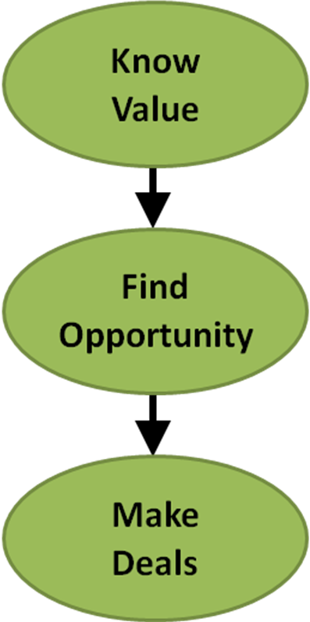
The Millionaire Real Estate Investor describes the models for buying your properties. This graphic depicts the general idea:

1. Know your target area, know the inventory, know the sold prices and the rental rates - then, when a good deal shows up, you will be ready to make a quick decision.

2. Seek the opportunities through various means. We always recommend using a real estate professional, but especially in the beginning. It doesn’t cost more, but may likely save you thousands.

3. Make the offers, stick to your model, be willing to walk-away if it isn’t the deal you need. ONLY buy when it fits your criteria and model - ABSOLUTELY.

The Proven Systems
Discussion Points:

Mortgages
- 30 year vs. 15 year
- 20% down or more?
- Qualifying issues
- Your first property - what to expect
- Your next property - what to expect

Property Management Company vs. Self-Management
- Pros and cons

- Make it part of your model - either way

Next Steps…
  - Read The Millionaire Real Estate Investor.
  - Talk to mortgage professional.
  - Talk to financial professional.
  - Let’s get together!

The Proven Systems

- The Proven Person
- Licensed REALTOR®
- Your credentials
(ABR, CRS, etc.)
- Other credentials
Your Name

